**FOREST MANAGEMENT SYSTEM**

**A project report submitted for the partial fulfilment of the award of degree of**

**Bachelor of Commerce (Information Technology)**

**Submitted**

**By**

**Name:    K.K NAME:K.KEERTHANA**

**H. T. No: 1214 17 405 016**

**Under the guidance**

**of**

**Name: Mr. SUNDEEP KADAMANDLA**



**St. Joseph’s Degree & PG College**

**(Affiliated to Osmania University)**

**Hyderabad – 500 029**

**2019-2020**

**ABSTRACT**

Forest Management System is a Management Software for the forest Monitoring and controlling the tree species in the forest. The Project developed in JAVA, mainly focus on basic Operations in a forest like Adding New tree species, tracking its life cycle, and Updating New Information about the forest, Viewing the forest fires and knowing the process aftermath of the fire and updating the information to the local news channels.

A computerized Forest Management system is needed mainly because of the lack of speed in the manual system. This system provides speed with accuracy. The new transaction entries can be made instantly. The modification and deletion of records regarding the transaction can be done in no time. The information flow will become faster. The coordination between different modules will also increase. The manpower and the paper work needed for maintaining the operation of the Forest will be reduced by the introduction of the computerized forest management system.

Lastly, Forest Management System allows the user to report the problem regarding the forest. This software package allows storing the details of all the data related to tree species and details regarding the tree harvesting and plantation. The system is strong enough to withstand regressive yearly operations under conditions where the database is maintained and cleared over a certain time of span. The implementation of the system in the organization will considerably reduce data entry, time and also provide readily calculated reports.

## 

**INDEX**

|  |  |  |
| --- | --- | --- |
| **S.NO.** | **CONTENTS** | **PAGE NO.** |
| **1** | **Introduction, Aim & Objectives** | 9-10 |
| **2** | **Existing System & Proposed System** | 11-12 |
| **3** | **Feasibility Study** | 13 |
| 3.1 | Technical Feasibility | 14 |
| 3.2 | Operational Feasibility | 14 |
| 3.3 | Economic Feasibility | 14 |
| **4** | **System Analysis** | 15-16 |
| 4.1 | **Software Requirement Specification (SRS)** | 16-17 |
| 4.1.1 | Software Requirements | 17 |
| 4.1.2 | Hardware Requirements | 17 |
| 4.1.3 | Functional Specifications | 17 |
| 4.2 | **Data Flow Diagrams (DFDs)** | 18-19 |
| **5** | **Design** | 20-25 |
| 5.1 | UML Diagrams | 21-22 |
| 5.2 | ER Diagrams | 22-24 |
| 5.3 | Tables And Data Dictionary | 24-25 |
| **6** | **Technology Used** | 26-31 |
| **7** | **Testing** | 32-35 |
| **8** | **Implementation And Maintenance** | 36-42 |
| **9** | **Report & Screenshots** | 43-51 |
| **10** | **Future Scope Of Project** | 52-53 |
| **11** | **Bibliography & Webliography** | 54-55 |

**1. INTRODUCTION, AIM & OBJECTIVES**

Our life is becoming more and more complex and faster day by day. Here computer is the most important thing that helps us to make human life fast. One computer can do the work of hundreds or thousands of people alone. At the same time a computer does the computational work efficiently and correctly. In almost every sphere of our life such as Government and Private Office, Business place, Store House, School, College, and various other organizations are interested to make their systems computerized. The Forest Management System is one that can be brought under computerized systems. Manually it is very tedious to keep all the required information. User Interface of this project is Menu driven based on Graphical User Interface (GUI).

➢ Data Accuracy: The computer handles all the valuable data. So there is a rare chance of wrong posting of data in database unless the end user does the mistake. Input device is designed to get confirmation of each transaction at least once.

➢ Eliminates paper work in forest and saves time.

➢ User Friendly GUI

➢ Data Storage, Retrieve, Update, Delete, and display of the records of the Forest can be done very quickly and effectively.

The main feature of this package is that it is user friendly. It requires less maintenance. The low level of complexity and high level of flexibility makes it more attractive to its user. Moreover, easy availability and low-cost requirements of the software and hardware used to develop, makes the system user friendly.

**2. EXISTING SYSTEM AND PROPOSED SYSTEM**

**2.   Existing System**

In the existing system of forest management system are managed through the working plans which are reviewed once in 10years. forest working plans are prepared for maintaining forest. In this system the users cannot report about the problems related to forest fires or any disasters. Users report information are generally collected from various sources which consume a lot of time which overloads the system. This becomes difficult to the officials to process.

**Proposed system**

The forest management system the information is being collected by forest administration at various levels. The forest management system is for the forest officials which maintains the database for the tree species and users reports the problems which will be handled by the management, reports on preventing forest fires, Information of harvesting trees. The manager provides the information regarding awareness on forest fires and the process of taking forward for the aftermath of a forest fire.

**3. FEASIBILITY STUDY**

Feasibility is the determination of whether or not a project is worth doing. The process followed in making this determination is called a Feasibility study. This type of study determines if a project can or should be taken. Once it has been determined that a project is feasible, the analyst can go ahead and prepare the project specification which finalizes project requirements. In the conduct of the feasibility study, the analyst takes into consideration three important, distinct but inter-related types of feasibility. They are:

➢ Technical Feasibility.

➢ Operational Feasibility.

➢ Economic Feasibility.

All projects are feasible - given unlimited resources and infinite time. Unfortunately, the development of a computer - based system or product is more likely plagued by a scarcity of resources and difficult (if not downright unrealistic) delivery dates. It is both necessary and prudent to evaluate the feasibility of a project at the earliest possible time.

**3.1 Technical Feasibility**

We can strongly say that the application is technically feasible, since there will not be much difficulty in getting required resources for the development and maintaining the system as well. All the resources needed for the development of the software as well as the maintenance of the same is available in the organization. Here we are utilizing the resources which are available already.

**3.2 Operational Feasibility**

The workings of the staff are reduced and made easier by the project. Not only that if the staffs are given proper training then it could also reduce unnecessary incorporation of staffs to perform comparative studies. Thus, the project is well suited to overcome organizational restrictions. Thus, considering the operational feasibility the development of the proposed system considered as operationally feasible for development.

**3.3 Economic Feasibility**

Development of this application is highly economically feasible. The organization need not spend much money for the development of the system. The only thing to be done is making an environment for the development with an effective supervision. If we are doing so, we can attain the maximum usability of the corresponding resources. Even after the development, the organization will not be in a condition to invest more in the organization. Therefore, the system is economically feasible.

**4.SYTEM ANALYSIS**

System Analysis is the process of gathering and interpreting facts, diagnosing problem and using the information to recommend improvement to the system. In brief, we can say that analysis specifies what the system should do. System analysis is thus a management technique, which helps in designing a new system or improving an existing system.

System Analysis takes into consideration the following:

➢ Types of Output Concerned: The objectives or goals are to be determined at first. This is achieved by determining the outputs that the system is supposed to generate. A computerized forest management system is needed mainly because of the lack of speed in the manual system of the forest. This system provides speed with accuracy.

➢ Types of inputs Concerned: Based on the output needed to be generated by the project, inputs needed for the projects are determined. In the computerized forest management system, the new transaction entries can be made instantly. The modification and deletion of records regarding the transaction can be done in no time. The information flow will become faster.

➢ Types of Storage Concerned: Types of storages are also needed to be determined they are the most important point taken into consideration. This computerized forest Management System uses oracle, it is a light weight, purely java based relational database. It has common SQL syntax. So, storage can be done without any issues.

**4.1 Software Requirement Specification (SRS)**

**Purpose**

The software Requirement specification is a description of all the functions of the forest management developed by the forest officials.

      The forest management system is for the forest officials which maintain the database for the trees species where the officials can have detailed information about the forest, users can also access his system for reporting problems. It will also manage all details of the forest which would compromise details of the tree species, forest fires, record of forest fires, and record of awareness information and the steps involved aftermath of forest fires.

**Document Conventions**

Heading: Font size:16

                Font style: Bold

                Font: Times New Roman

Subheading: Font size:14

                Font style: Bold

                Font: Times New Roman

Content: Font size :12

                Font: Times New Roman

**Product Scope**

This Forest Management System will store all the details of the forest trees effects, and awareness records should be updated or modified or deleted to keep the information up to date.

**Overall Description**

This project is to facilitate the forest officials in easy access of the information about forest in no time

**Product Perspective**

1.In forest management the forest officer has to manage all the details of the forest .

2.The forest officer has to collect all the information about the forest environment and have a record of it.

 3.The forest officer has to arrange all the information according to the changes happening in the forest. If any modifications or updates are required it should be done by the officer.

4.Hence, the forest management system would maintain the whole database of the forest species and information on any effects of forest fires and maintain records.

**Product Functions**

The forest management system is developed to as an attempt to take a record of forest and the forest species and the record of the consequences in the forest. The system would provide the facility of viewing the information of the trees species available and the forest fires and the awareness information

    This system would help the officials to search for the tree species and information and requirements.

**4.1.1Software Requirements**

The software interface uses a:

OS: Linux/windows

Web server: Apache server

Data base: Oracle database

Language: JavaScript/PHP/HTML.

**4.1.2 Hardware Interfaces**

➢ Processor: Pentium 4 or better

➢ RAM: 128 MB or more

➢ Hard Disk: 20GB

➢ Monitor: Any

➢ Keyboard: 122 Keys

**4.1.3 Functional requirements:**

**1.Log in**: This functionality allows the users and the employees to log in the system to access the information

**2.View Reports:** This functionality allows the management to view the reports of the users.

**3.Update information:** This functionality allows the forest management to update the information regarding the forest.

**4.View updates:** This functionality allows the forest management to view the updates up to date.

**5.Update problems:** This functionality allows the forest management to update the problems of the forest.

**6.Add species:** This functionality allows the management to add different kinds of species to the system.

**4.2 DATA FLOW DIAGRAM(DFD’s)**

A data flow diagram (DFD) maps out the flow of information for any process or system. It uses defined symbols like rectangles, circles and arrows, plus short text labels, to show data inputs, outputs, storage points and the routes between each destination. Data flowcharts can range from simple, even hand-drawn process overviews, to in-depth, multi- level DFDs that dig progressively deeper into how the data is handled. They can be used to analyse an existing system or model a new one. Like all the best diagrams and charts, a DFD can often visually “say” things that would be hard to explain in words, and they work for both technical and nontechnical audiences, from developer to CEO. That’s why DFDs remain so popular after all these years. While they work well for data flow software and systems, they are less applicable nowadays to visualizing interactive, real-time or database-oriented software or systems.

**Basic notations:**

**➢ Dataflow:** The route that data takes between the external entities, processes and data stores. It portrays the interface between the other components and is shown with arrows, typically labelled with a short data name.

**➢ Process:** Any process that changes the data, producing an output. It might perform computations, or sort data based on logic, or direct the data flow based on business rules. A short label is used to describe the process.

**➢ External entity:** An outside system that sends or receives data, communicating with the system being diagrammed. They are the sources and destinations of information entering or leaving the system. 13

They might be an outside organization or person, a computer system or a business system. They are also known as terminators, sources and sinks or actors. They are typically drawn on the edges of the diagram.

**➢ Data store:** Files or repositories that hold information for later use, such as a database table or a membership form. Each data store receives a simple label.

**DATAFLOWDIAGRAM**

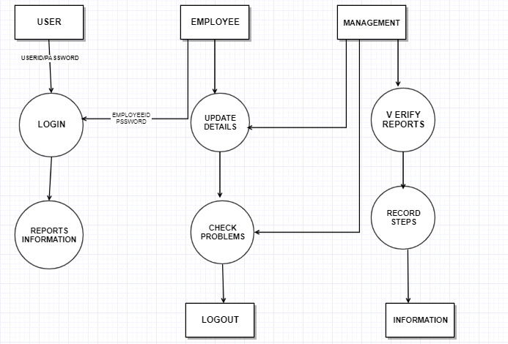

**5.DESIGN**

**5.1 UML Diagrams:**

The Unified Modelling Language allows the software engineer to express an analysis model using the modelling notation that is governed by a set of syntactic semantic and pragmatic rules.

A UML system is represented using five different views that describe the system from distinctly different perspective. Each view is defined by a set of diagrams, which is as follows.

**User Model View:**

➢ This view represents the system from the user’s perspective

➢ The analysis representation describes a usage scenario from the end-user’s perspective.

**Structural model view:**

➢ In this model the data and functionality are arrived from inside the system.

➢ This model view models the static structures.

**Behavioural Model View:**

It represents the dynamic of behavioural as parts of the system, depicting the interactions of collection between various structural elements described in the user model and structural model view.

**Implementation Model View:**

In this the structural and behavioural as parts of the system are represented as they are to be built.

**Environmental Model View:**

In this the structural and behavioural aspect of the environment in which the system is to be implemented are represented.

UML is specifically constructed through two different domains they are:

➢ UML Analysis modelling, this focuses on the user model and structural model views of the system.

➢ UML design modelling, which focuses on the behavioural modelling, implementation modelling and environmental model views.

Use case Diagrams represent the functionality of the system from a user’s point of view. Use cases are used during requirements elicitation and analysis to represent the functionality of the system. Use cases focus on the behaviour of the system from external point of view.

Actors are external entities that interact with the system. Examples of actors include users like administrator, Counsellor, Student …etc., or another system like central database.

**USE CASE DIAGRAM**

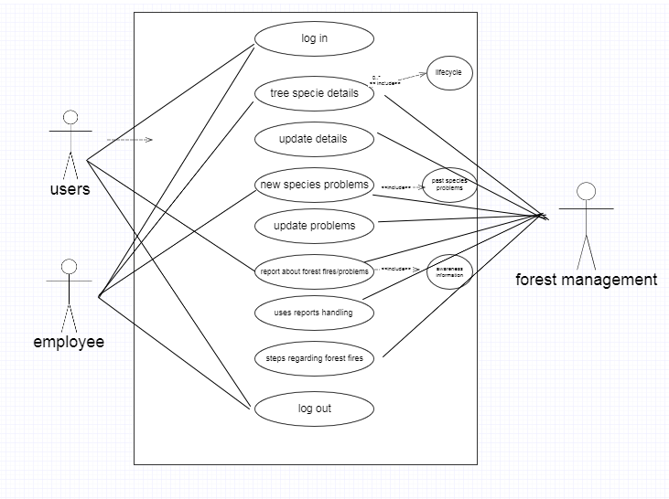

**5.2 ER Diagram:**

An entity–relationship model (ER model for short) describes interrelated things of interest in a specific domain of knowledge. A basic ER model is composed of entity types (which classify the things of interest) and specifies relationships that can exist between instances of those entity types.

In software engineering, an ER model is commonly formed to represent things that a business needs to remember in order to perform business processes. Consequently, the ER model becomes an abstract data model, which defines a data or information structure which can be implemented in a database, typically a relational database.

**Components:**

➢ Entity: Entities are represented by means of rectangles. Rectangles are named with the entity set they represent.

➢ Attribute: Attributes are the properties of entities. Attributes are represented by means of ellipses. Every ellipse represents one attribute and is directly connected to its entity (rectangle). If the attributes are composite, they are further divided in a tree like structure. Every node is then connected to its attribute. That is, composite attributes are represented by ellipses that are connected with an ellipse. Multivalued attributes are depicted by double ellipse. Derived attributes are depicted by dashed ellipse.

➢ Relationship: Relationships are represented by diamond-shaped box. Name of the relationship is written inside the diamond-box. All the entities (rectangles) participating in a relationship, are connected to it by a line.

**ER Diagram:**

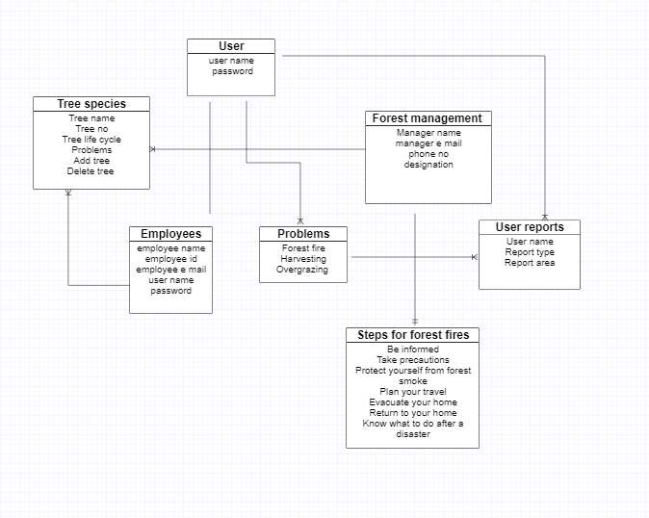

**Class Diagram**

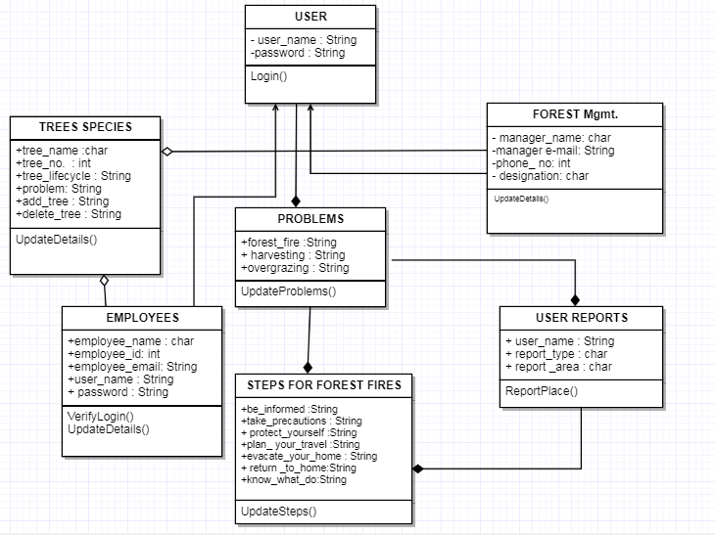

**5.3 Tables and Data Dictionary**

**Login table:**

|  |  |  |
| --- | --- | --- |
| FIELD | DATA TYPE | DEFAULT |
| Username | varchar | Not null |
| Password | varchar | Not null |
| Admin | varchar | Not null |

**Species table:**

|  |  |  |
| --- | --- | --- |
| FIELD | DATATYPE | DEFAULT |
| Id | number | Not null |
| Name | varchar | Not null |
| Meters | varchar | Not null |
| Qty | number | Not null |

**Reports table:**

|  |  |  |
| --- | --- | --- |
| FIELD | DATATYPE | DEFAULT |
| Id | number | Not null |
| Name | varchar | Not null |
| Complaint | varchar | Not null |

**6. TECHNOLOGY USED**

JAVA.

**Features of JAVA:**

ü **Simple:**Java is a simple programming language which works on any system and consumes less money. Difficult concepts of C and C++ are omitted in Java.

ü **Object oriented:**Java is on object-oriented language which means java programs use object and classes. An object is anything that really exists in the real world and can be distinguish from others. A group of objects exhibiting same behaviour will come under same group called as class.

ü **System independent:**Java byte code is not machine independent. It can be executed on any machine with any operating system and processor.

ü **Platform independent:** Unlike many other programming languages including C and C++, when Java is compiled, it is not compiled into platform specific machine, rather into platform-independent byte code. This byte code is distributed over the web and interpreted by the Virtual Machine (JVM) on whichever platform it is being run on.

ü **Simple;**Java is designed to be easy to learn. If you understand the basic concept of OOP Java, it would be easy to master.

ü **Secure:** With Java's secure feature it enables to develop virus-free, tamper-free systems. Authentication techniques are based on public-key encryption.

ü **Portable:** Being architecture-neutral and having no implementation dependent aspects of the specification makes Java portable. The compiler in Java is written in ANSI C with a clean portability boundary, which is a POSIX subset.

ü **Robust:** Java makes an effort to eliminate error-prone situations by emphasizing mainly on compile time error checking and runtime checking.

ü **Multi-threading:**With Java's multithreaded feature it is possible to write programs that can perform many tasks simultaneously. This design feature allows the developers to construct interactive applications that can run smoothly.

ü **High performance:**With the use of Just-In-Time compilers, Java enables high performance.

ü **Interpreted:** Java byte code is translated on the fly to native machine instructions and is not stored anywhere. The development process is more rapid and analytical since the linking is an incremental and light-weight process.

ü **Distributed:** Java is designed for the distributed environment of the internet.

ü   **Dynamic:** Java is considered to be more dynamic than C or C++ since it is designed to adapt to an evolving environment. Java programs can carry an extensive amount of run-time information that can be used to verify and resolve accesses to objects at run-time.

**Versions used:**

JDK: jdk1.8.0_231

JRE: jre1.8.0_231

**JDBC:**

Java JDBC is a java API to connect and execute query with the database. JDBC API uses jdbc drivers to connect with the database.

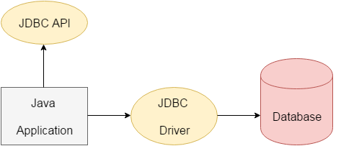

**Why use JDBC?**

Before JDBC, ODBC API was the database API to connect and execute query with the database. But ODBC API uses ODBC driver which is written in C language (i.e. platform dependent and unsecured). That is why Java has defined its own API (JDBC API) that uses JDBC drivers (written in Java language).

**What is API?**

API (Application programming interface) is a document that contains description of all the features of a product or software. It represents classes and interfaces that software programs can follow to communicate with each other. An API can be created for applications, libraries, operating systems, etc

**JDBC Driver Types:**

The JDBC drivers that we are aware of at this time fit into one of four categories:

* JDBC-ODBC bridge plus ODBC driver
* Native-API partly-Java driver
* JDBC-Net pure Java driver
* Native-protocol pure Java driver

**Apache Tomcat:**

**Version:** **apache-tomcat-9.0.30**

Apache Tomcat is an open source web server and servlet container developed by the Apache Software Foundation. Basically, it implements the Java Servlet and the Java Server Pages (JSP) specifications from Sun Microsystem, and provides a "pure Java" HTTP web server environment for Java code to run in. In the simplest configuration Tomcat runs in a single operating system process. The process runs a Java virtual machine (JVM) and every single HTTP request from a browser to is processed in the Tomcat process in a separate thread.

Apache Tomcat includes tools for configuration and management, but can also be configured by editing XML configuration files.

In simple words, Tomcat acts or behaves as a *development* server on your desktop to use for testing when building applications that use JSF 2, servlets/JSP, or other Java-based dynamic Web technologies. Regardless of what deployment server you use, you'll want a standalone server on you r desktop to use for development. By far the best way to use Tomcat for development purposes is from inside Eclipse or another IDE.

**Eclipse**

**Eclipse** is an [integrated development environment](https://en.wikipedia.org/wiki/Integrated_development_environment) (IDE) used in [computer programming](https://en.wikipedia.org/wiki/Computer_programming).[[6]](https://en.wikipedia.org/wiki/Eclipse_(software)#cite_note-6) It contains a base [workspace](https://en.wikipedia.org/wiki/Workspace) and an extensible [plug-in](https://en.wikipedia.org/wiki/Plug-in_(computing)) system for customizing the environment. Eclipse is written mostly in [Java](https://en.wikipedia.org/wiki/Java_(programming_language)) and its primary use is for developing Java applications, but it may also be used to develop applications in other [programming languages](https://en.wikipedia.org/wiki/Programming_language) via plug-ins, including [Ada](https://en.wikipedia.org/wiki/Ada_(programming_language)), [ABAP](https://en.wikipedia.org/wiki/ABAP), [C](https://en.wikipedia.org/wiki/C_(programming_language)), [C++](https://en.wikipedia.org/wiki/C%2B%2B), [C#](https://en.wikipedia.org/wiki/C_Sharp_(programming_language)), [Clojure](https://en.wikipedia.org/wiki/Clojure), [COBOL](https://en.wikipedia.org/wiki/COBOL), [D](https://en.wikipedia.org/wiki/D_(programming_language)), [Erlang](https://en.wikipedia.org/wiki/Erlang_(programming_language)), [Fortran](https://en.wikipedia.org/wiki/Fortran), [Groovy](https://en.wikipedia.org/wiki/Groovy_(programming_language)), [Haskell](https://en.wikipedia.org/wiki/Haskell_(programming_language)), [JavaScript](https://en.wikipedia.org/wiki/JavaScript), [Julia](https://en.wikipedia.org/wiki/Julia_(programming_language)),[[7]](https://en.wikipedia.org/wiki/Eclipse_(software)#cite_note-7) [Lasso](https://en.wikipedia.org/wiki/Lasso_(programming_language)), [Lua](https://en.wikipedia.org/wiki/Lua_(programming_language)), [NATURAL](https://en.wikipedia.org/wiki/Software_AG), [Perl](https://en.wikipedia.org/wiki/Perl), [PHP](https://en.wikipedia.org/wiki/PHP), [Prolog](https://en.wikipedia.org/wiki/Prolog), [Python](https://en.wikipedia.org/wiki/Python_(programming_language)), [R](https://en.wikipedia.org/wiki/R_(programming_language)), [Ruby](https://en.wikipedia.org/wiki/Ruby_(programming_language)) (including [Ruby on Rails](https://en.wikipedia.org/wiki/Ruby_on_Rails) framework), [Rust](https://en.wikipedia.org/wiki/Rust_(programming_language)), [Scala](https://en.wikipedia.org/wiki/Scala_(programming_language)), and [Scheme](https://en.wikipedia.org/wiki/Scheme_(programming_language)). It can also be used to develop documents with [LaTeX](https://en.wikipedia.org/wiki/LaTeX) (via a eclipse plug-in) and packages for the software [Mathematica](https://en.wikipedia.org/wiki/Mathematica). Development environments include the Eclipse Java development tools (JDT) for Java and Scala, Eclipse CDT for C/C++, and Eclipse PDT for PHP, among others.

**Java servlet**

A Java servlet processes or stores a [Java class](https://en.wikipedia.org/wiki/Java_class) in [Java EE](https://en.wikipedia.org/wiki/Java_EE) that conforms to the Java Servlet API,[[1]](https://en.wikipedia.org/wiki/Java_servlet#cite_note-1) a standard for implementing Java classes that respond to requests. Servlets could in principle communicate over any [client–server](https://en.wikipedia.org/wiki/Client%E2%80%93server_model) protocol, but they are most often used with [HTTP](https://en.wikipedia.org/wiki/Hypertext_Transfer_Protocol). Thus "servlet" is often used as shorthand for "HTTP servlet".[[2]](https://en.wikipedia.org/wiki/Java_servlet#cite_note-r1-2) Thus, a [software developer](https://en.wikipedia.org/wiki/Software_developer) may use a servlet to add [dynamic content](https://en.wikipedia.org/wiki/Dynamic_web_page) to a [web server](https://en.wikipedia.org/wiki/Web_server) using the [Java platform](https://en.wikipedia.org/wiki/Java_platform). The generated content is commonly [HTML](https://en.wikipedia.org/wiki/HTML), but may be other data such as [XML](https://en.wikipedia.org/wiki/XML) and more commonly, JSON. Servlets can maintain [state](https://en.wikipedia.org/wiki/State_(computer_science)) in [session](https://en.wikipedia.org/wiki/Session_(computer_science)) variables across many server transactions by using [HTTP cookies](https://en.wikipedia.org/wiki/HTTP_cookie), or [URL mapping](https://en.wikipedia.org/wiki/URL_mapping).

**Java Script let**

Scriptlet is similar to expression except for the equal sign “=”. You can insert any plain Java code inside a scriptlet. Because of mixing between Java code and HTML make JSP page difficult to maintain so scriptlet is not recommended for future development. The following illustrates the syntax of scriptlet:

<% // any java source code here %>

**Oracle** **Database**:

An Oracle **database** is a collection of data treated as a unit. The purpose of a database is to store and retrieve related information. A database server is the key to solving the problems of information management. In general, a [server](https://docs.oracle.com/cd/B19306_01/server.102/b14220/glossary.htm#i432724) reliably manages a large amount of data in a multiuser environment so that many users can concurrently access the same data. All this is accomplished while delivering high performance. A database server also prevents unauthorized access and provides efficient solutions for failure recovery.

Oracle Database is the first database designed for enterprise grid computing, the most flexible and cost effective way to manage information and applications. Enterprise grid computing creates large pools of industry-standard, modular storage and servers. With this architecture, each new system can be rapidly provisioned from the pool of components. There is no need for peak workloads, because capacity can be easily added or reallocated from the resource pools as needed.

The database has **logical structures** and **physical structures**. Because the physical and logical structures are separate, the physical storage of data can be managed without affecting the access to logical storage structures.

**CSS (Cascading Style Sheets**)

**Cascading Style Sheets** (**CSS**) is a [style sheet language](https://en.wikipedia.org/wiki/Style_sheet_language) used for describing the [presentation](https://en.wikipedia.org/wiki/Presentation_semantics) of a document written in a [mark-up language](https://en.wikipedia.org/wiki/Markup_language) like [HTML](https://en.wikipedia.org/wiki/HTML).[[1]](https://en.wikipedia.org/wiki/Cascading_Style_Sheets#cite_note-1) CSS is a cornerstone technology of the [World Wide Web](https://en.wikipedia.org/wiki/World_Wide_Web), alongside HTML and [JavaScript](https://en.wikipedia.org/wiki/JavaScript).[[2]](https://en.wikipedia.org/wiki/Cascading_Style_Sheets#cite_note-2)

CSS is designed to enable the separation of presentation and content, including [layout](https://en.wikipedia.org/wiki/Page_layout), [colors](https://en.wikipedia.org/wiki/Color" \o "Color), and [fonts](https://en.wikipedia.org/wiki/Typeface).[[3]](https://en.wikipedia.org/wiki/Cascading_Style_Sheets#cite_note-3) This separation can improve content [accessibility](https://en.wikipedia.org/wiki/Accessibility), provide more flexibility and control in the specification of presentation characteristics, enable multiple [web pages](https://en.wikipedia.org/wiki/Web_page) to share formatting by specifying the relevant CSS in a separate .css file, and reduce complexity and repetition in the structural content.

**Hypertext Mark-up Language** (**HTML**)

**Hypertext Mark-up Language** (**HTML**) is the standard [mark-up language](https://en.wikipedia.org/wiki/Markup_language) for documents designed to be displayed in a [web browser](https://en.wikipedia.org/wiki/Web_browser). It can be assisted by technologies such as [Cascading Style Sheets](https://en.wikipedia.org/wiki/Cascading_Style_Sheets) (CSS) and [scripting languages](https://en.wikipedia.org/wiki/Scripting_language) such as [JavaScript](https://en.wikipedia.org/wiki/JavaScript).

[Web browsers](https://en.wikipedia.org/wiki/Web_browser) receive HTML documents from a [web server](https://en.wikipedia.org/wiki/Web_server) or from local storage and [render](https://en.wikipedia.org/wiki/Browser_engine) the documents into multimedia web pages. HTML describes the structure of a web page [semantically](https://en.wikipedia.org/wiki/Semantic_Web) and originally included cues for the appearance of the document.

[HTML elements](https://en.wikipedia.org/wiki/HTML_element) are the building blocks of HTML pages. With HTML constructs, [images](https://en.wikipedia.org/wiki/HTML_element#Images_and_objects) and other objects such as [interactive forms](https://en.wikipedia.org/wiki/Fieldset) may be embedded into the rendered page. HTML provides a means to create [structured documents](https://en.wikipedia.org/wiki/Structured_document) by denoting structural [semantics](https://en.wikipedia.org/wiki/Semantics) for text such as headings, paragraphs, lists, [links](https://en.wikipedia.org/wiki/Hyperlink), quotes and other items. HTML elements are delineated by *tags*, written using [angle brackets](https://en.wikipedia.org/wiki/Bracket#Angle_brackets). Tags such as <**img** /> and <**input** /> directly introduce content into the page. Other tags such as <**p**> surround and provide information about document text and may include other tags as sub-elements. Browsers do not display the HTML tags, but use them to interpret the content of the page.

**7.TESTING**

Software Testing is the process used to help identify the correctness, completeness, security, and quality of developed computer software. Testing is a process of technical investigation, performed on behalf of stakeholders, that is intended to reveal quality-related information about the product with respect to the context in which it is intended to operate. This includes, but is not limited to, the process of executing a program or application with the intent of finding errors. Quality is not an absolute; it is value to some person. With that in mind, testing can never completely establish the correctness of arbitrary computer software; testing furnishes a criticism or comparison that compares the state and behaviour of the product against a specification. An important point is that software testing should be distinguished from the separate discipline of Software Quality Assurance (SQA), which encompasses all business process areas,not just testing.

There are many approaches to software testing, but effective testing of complex products is essentially a process of investigation, not merely a matter of creating and following routine procedure. One definition of testing is the process of questioning a product in order to evaluate it & where the questions are operations the tester attempts to execute with the product, and the product answers with its behaviour in reaction to the probing of the tester. Although most of the intellectual processes of testing are nearly identical to that of review or inspection, the word testing is connoted to mean the dynamic analysis of the product—putting the product through its paces. Some of the common quality attributes include capability, reliability, efficiency, portability, maintainability, compatibility and usability. A good test is sometimes described as one which reveals an error; however, more recent thinking suggests that a good test is one which reveals information of interest to someone who matters within the project community.

**Introduction:**

In general, software engineers distinguish software faults from software failures. In case of a failure, the software does not do what the user expects. A fault is a programming error that may or may not actually manifest as a failure. A fault can also be described as an error in the correctness of the semantic of a computer program. A fault will become a failure if the exact computation conditions are met, one of them being that the faulty portion of computer software executes on the CPU.

Software testing may be viewed as a sub-field of Software Quality Assurance but typically exists independently (and there may be no SQA areas in some companies). In SQA, software process specialists and auditors take a broader view on software and its development. They examine and change the software engineering process itself to reduce the number of faults that end up in the code or deliver faster.

A problem with software testing is that the number of defects in a software product can be very large, and the number of configurations of the product larger still. Bugs that occur infrequently are difficult to find in testing. A rule of thumb is that a system that is expected to function without faults for a certain length of time must have already been tested for at least that length of time. This has severe consequences for projects to write long-lived reliable software.

A common practice of software testing is that it is performed by an independent group of testers after the functionality is developed but before it is shipped to the customer. This practice often results in the testing phase being used as project buffer to compensate for project delays. Another practice is to start software testing at the same moment the project

starts and it is a continuous process until the project finishes. It is commonly believed that the earlier a defect is found the cheaper it is to fix it.

**Levels of Testing:**

|  |  |  |  |  |  |  |  |  |  |  |  |  |  |  |  |
| --- | --- | --- | --- | --- | --- | --- | --- | --- | --- | --- | --- | --- | --- | --- | --- |
| |  |  |  |  |  |  |  |  |  |  |  |  |  |  |  | | --- | --- | --- | --- | --- | --- | --- | --- | --- | --- | --- | --- | --- | --- | --- | | ***Module1***                  ***Module2***                       ***Module3***   |  |  |  |  |  |  |  |  |  |  |  |  |  |  | | --- | --- | --- | --- | --- | --- | --- | --- | --- | --- | --- | --- | --- | --- | | ***Units***   |  |  |  | | --- | --- | --- | |  |  |  | |  | ***Units***   |  |  |  | | --- | --- | --- | |  |  |  | |  | ***Units***   |  |  |  | | --- | --- | --- | |  |  |  | |                         i/p ***Integration***   o/p i/p       ***Integration o/p*** |   ***System Testing: Presentation + business +Databases***  ***UAT: user acceptance testing*** |

**Software Testing Life Cycle (STLC):**

**Test Planning:**

Expected value: is nothing but expected behaviour of application.

Actual value:  is nothing but actual behaviour of application

**Bug Tracing:**

Collect all the failed cases, prepare documents.

**Reporting:**

Prepare document (status of the application)

**Test Case Document (TCD):**

Test Case Document Contains-

* Test scope
* Test Scenario
* Test Procedure

**Testing:**

➢ The process of executing a system with the intent of finding an error.

➢ Testing is defined as the process in which defects are identified, isolated, subjected for rectification and ensured that product is defect free in order to produce the quality product and hence customer satisfaction.

➢ Quality is defined as justification of the requirements

➢ Defect is nothing but bug.

➢ Testing --- The presence of bugs

➢ Testing can demonstrate the presence of bugs, but not their absence

➢ Debugging and Testing are not the same thing!

➢ Testing is a systematic attempt to break a program or the AUT

➢ Debugging is the art or method of uncovering why the script /program did not execute properly.

**Testing Methodologies:**

➢ Black box Testing: is the testing process in which tester can perform testing on an application without having any internal structural knowledge of application. Usually Test Engineers are involved in the black box testing.

➢ White box Testing: is the testing process in which tester can perform testing on an application with having internal structural knowledge. Usually The Developers are involved in white box testing.

➢ Grey Box Testing: is the process in which the combination of black box and white box tonics are used.

**8.IMPLEMENTATION AND MAINTENANCE**

Implementation is a process of ensuring that the information system is operational. It involves −

* Constructing a new system from scratch
* Constructing a new system from the existing one.

Implementation allows the users to take over its operation for use and evaluation. It involves training the users to handle the system and plan for a smooth conversion.

## **Training**

The personnel in the system must know in detail what their roles will be, how they can use the system, and what the system will or will not do. The success or failure of well-designed and technically elegant systems can depend on the way they are operated and used.

### **Training Systems Operators**

Systems operators must be trained properly such that they can handle all possible operations, both routine and extraordinary. The operators should be trained in what common malfunctions may occur, how to recognize them, and what steps to take when they come.

Training involves creating troubleshooting lists to identify possible problems and remedies for them, as well as the names and telephone numbers of individuals to contact when unexpected or unusual problems arise.

Training also involves familiarization with run procedures, which involves working through the sequence of activities needed to use a new system.

### **User Training**

* End-user training is an important part of the computer-based information system development, which must be provided to employees to enable them to do their own problem solving.
* User training involves how to operate the equipment, troubleshooting the system problem, determining whether a problem that arose is caused by the equipment or software.
* Most user training deals with the operation of the system itself. The training courses must be designed to help the user with fast mobilization for the organization.

### **Training Guidelines**

* Establishing measurable objectives
* Using appropriate training methods
* Selecting suitable training sites
* Employing understandable training materials

## **Training Methods**

### **Instructor-led training**

It involves both trainers and trainees, who have to meet at the same time, but not necessarily at the same place. The training session could be one-on-one or collaborative. It is of two types −

**Virtual Classroom**

In this training, trainers must meet the trainees at the same time, but are not required to be at the same place. The primary tools used here are: video conferencing, text based Internet relay chat tools, or virtual reality packages, etc.

**Normal Classroom**

The trainers must meet the trainees at the same time and at the same place. They primary tools used here are blackboard, overhead projectors, LCD projector, etc.

### **Self-Paced Training**

It involves both trainers and trainees, who do not need to meet at the same place or at the same time. The trainees learn the skills themselves by accessing the courses at their own convenience. It is of two types −

**Multimedia Training**

In this training, courses are presented in multimedia format and stored on CD-ROM. It minimizes the cost in developing an in-house training course without assistance from external programmers.

**Web-based Training**

In this training, courses are often presented in hyper media format and developed to support internet and intranet. It provides just–in-time training for end users and allow organization to tailor training requirements.

## **Conversion**

It is a process of migrating from the old system to the new one. It provides understandable and structured approach to improve the communication between management and project team.

### **Conversion Plan**

It contains description of all the activities that must occur during implementation of the new system and put it into operation. It anticipates possible problems and solutions to deal with them.

It includes the following activities −

* Name all files for conversions.
* Identifying the data requirements to develop new files during conversion.
* Listing all the new documents and procedures that are required.
* Identifying the controls to be used in each activity.
* Identifying the responsibility of person for each activity.
* Verifying conversion schedules.

### **Conversion Methods**

The four methods of conversion are −

* Parallel Conversion
* Direct Cutover Conversion
* Pilot Approach
* Phase-In Method

|  |  |  |  |
| --- | --- | --- | --- |
| **Method** | **Description** | **Advantages** | **Disadvantages** |
| Parallel Conversion | Old and new systems are used simultaneously. | Provides fallback when new system fails.  Offers greatest security and ultimately testing of new system. | Causes cost overruns.  New system may not get fair trial. |
| Direct Cutover Conversion | New system is implemented and old system is replaced completely. | Forces users to make new system work  Immediate benefit from new methods and control. | No fall back if problems arise with new system  Requires most careful planning |
| Pilot Approach | Supports phased approach that gradually implement system across all users | Allows training and installation without unnecessary use of resources.  Avoid large contingencies from risk management. | A long term phasein causes a problem of whether conversion goes well or not. |
| Phase-In Method | Working version of system implemented in one part of organization based on feedback, it is installed throughout the organization all alone or stage by stage. | Provides experience and line test before implementation  When preferred new system involves new technology or drastic changes in performance. | Gives impression that old system is erroneous and it is not reliable. |

### **File Conversion**

It is a process of converting one file format into another. For example, file in WordPerfect format can be converted into Microsoft Word.

For successful conversion, a conversion plan is required, which includes −

* Knowledge of the target system and understanding of the present system
* Teamwork
* Automated methods, testing and parallel operations
* Continuous support for correcting problems
* Updating systems/user documentation, etc

Many popular applications support opening and saving to other file formats of the same type. For example, Microsoft Word can open and save files in many other word processing formats.

### **Post-Implementation Evaluation Review (PIER)**

PIER is a tool or standard approach for evaluating the outcome of the project and determine whether the project is producing the expected benefits to the processes, products or services. It enables the user to verify that the project or system has achieved its desired outcome within specified time period and planned cost.

PIER ensures that the project has met its goals by evaluating the development and management processes of the project.

### **Objectives of PIER**

The objectives of having a PIER are as follows −

* To determine the success of a project against the projected costs, benefits, and timelines.
* To identify the opportunities to add additional value to the project.
* To determine strengths and weaknesses of the project for future reference and appropriate action.
* To make recommendations on the future of the project by refining cost estimating techniques.

The following staff members should be included in the review process −

* Project team and Management
* User staff
* Strategic Management Staff
* External users

## **System Maintenance / Enhancement**

Maintenance means restoring something to its original conditions. Enhancement means adding, modifying the code to support the changes in the user specification. System maintenance conforms the system to its original requirements and enhancement adds to system capability by incorporating new requirements.

Thus, maintenance changes the existing system, enhancement adds features to the existing system, and development replaces the existing system. It is an important part of system development that includes the activities which corrects errors in system design and implementation, updates the documents, and tests the data.

### **Maintenance Types**

System maintenance can be classified into three types −

* **Corrective Maintenance** − Enables user to carry out the repairing and correcting leftover problems.
* **Adaptive Maintenance** − Enables user to replace the functions of the programs.
* **Perfective Maintenance** − Enables user to modify or enhance the programs according to the users’ requirements and changing needs.

**Connection code:**

package DBConnection;

import java.sql. Connection;

import java.sql.Statement;

import java.sql. DriverManager;

import java.sql.ResultSet;

import java.sql.SQLException;

public class Fms {

public static void main(String[] args) {

String url="jdbc:oracle:thin:@localhost:1521:xe";

String uId="sjc";

String pwd="sjc";

Connection con = null;

Statement stmt = null;

try {

DriverManager.registerDriver(new oracle.jdbc.driver.OracleDriver());

con=DriverManager.getConnection(url,uId,pwd);

//step3 create the statement object

stmt=con.createStatement();

//step4 execute query

ResultSet rs=stmt.executeQuery("select * from logindetails");

System.out.println("connection object;"+con);

while(rs.next()) {

System.out.println(rs.getString(1)+" "+rs.getString(2));

}

System.out.println("connection object;"+11);

con.close();

}catch(Exception e) {

e.printStackTrace();

}

}

}

**9. REPORTS AND SCREENSHOTS**

The forest management system consists of forest administrator (admin)and the customer (user). The admin’s page is shown below:

**ADMIN’S PAGE:**

**Login page:**

When the administrator (admin) visits the website of the forest management system the admin gets the log in page where he must log in that with his ID and Password.

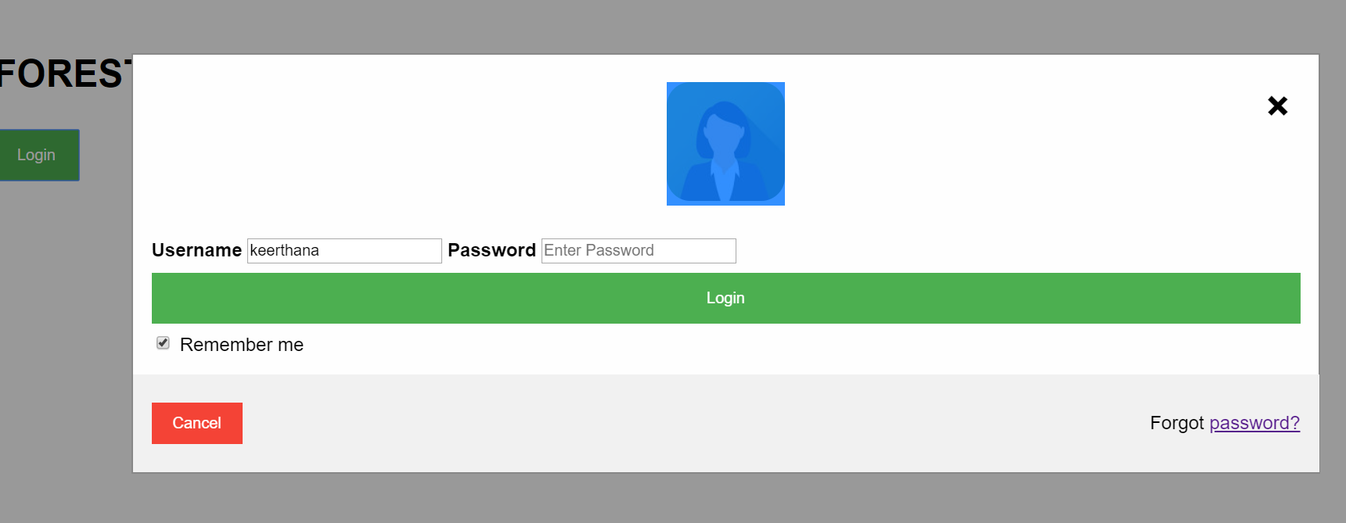

**Home page:**

After logging in the website, the admin can visit home page where he can manage all the details about the forest as shown below. In this home page various things are included such that the forest officials can make the changes happening in the forest.

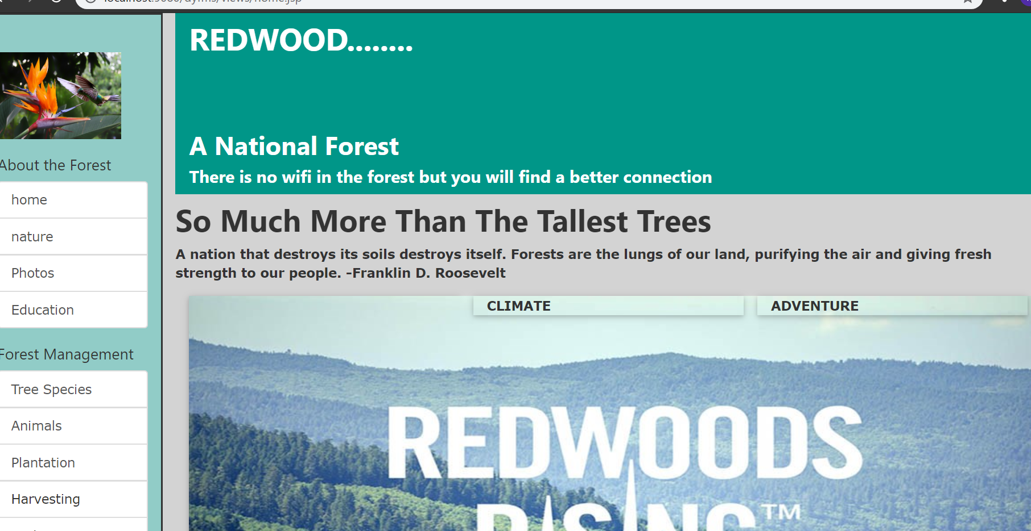

**Photos page:**

This photos page of the forest can show various plants gallery available in the given region of the forest.

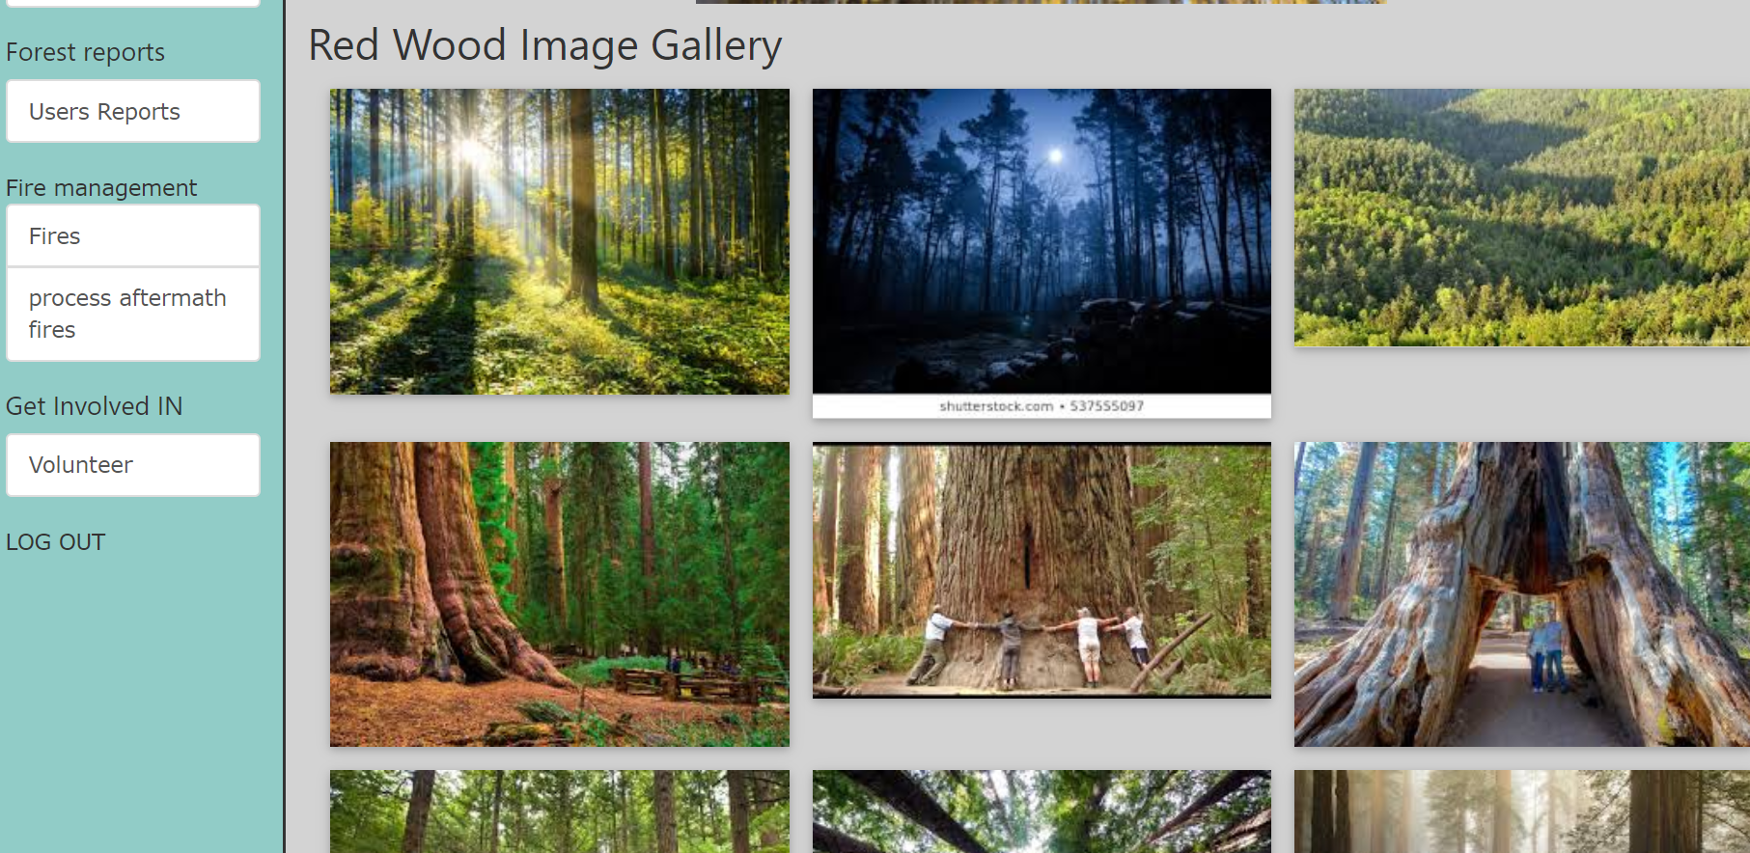

**Education page:**

This page shows the viewers about various education facilities available about the forest.

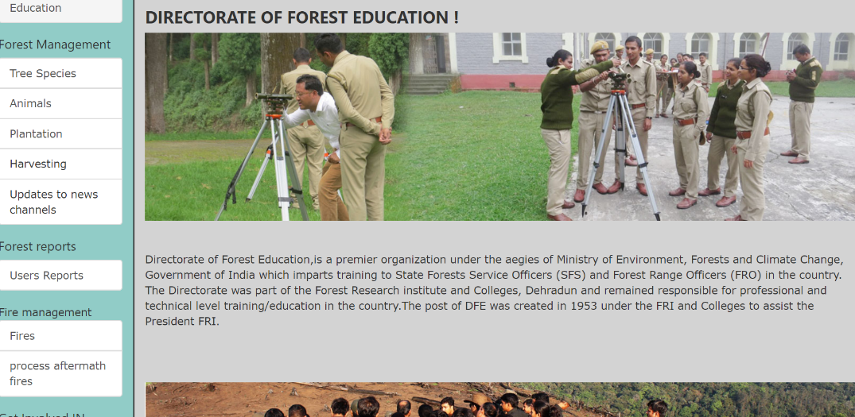

**Admin Tree Species page:**

This admin tree species page shows the available tree species in the given region of the forest. In this page the admin can make changes about the tree species. He can also add, update, delete the tree species. He can also update the details like meters and quantity of the species.

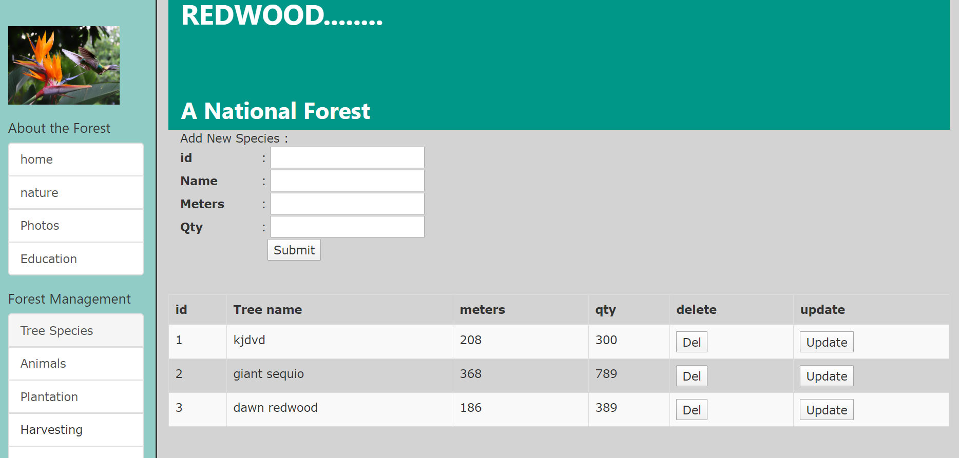

**Admin Plantation page:**

When the forest officials have the program about planting the plants in the forest the admin must note each and every plant that had been planted.

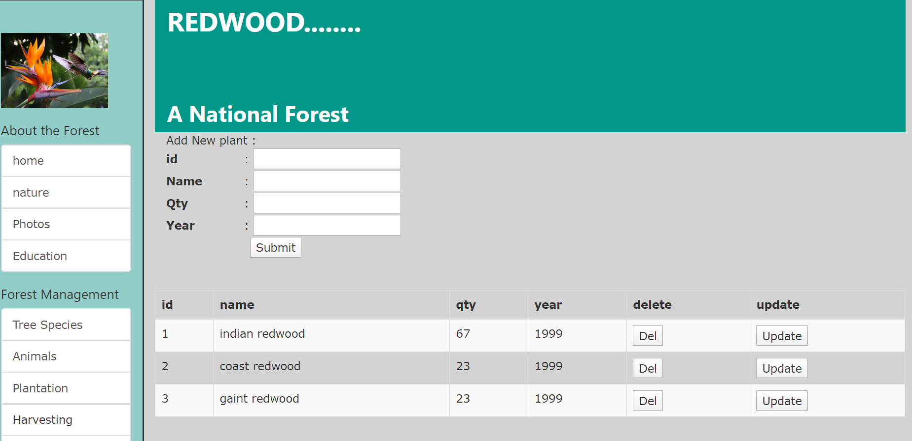

**Admin Harvesting page:**

This harvesting page indicates that whenever the forest plants are harvested the list of the harvested plants, quantity and in which month it has been harvested must be noted by the officer.

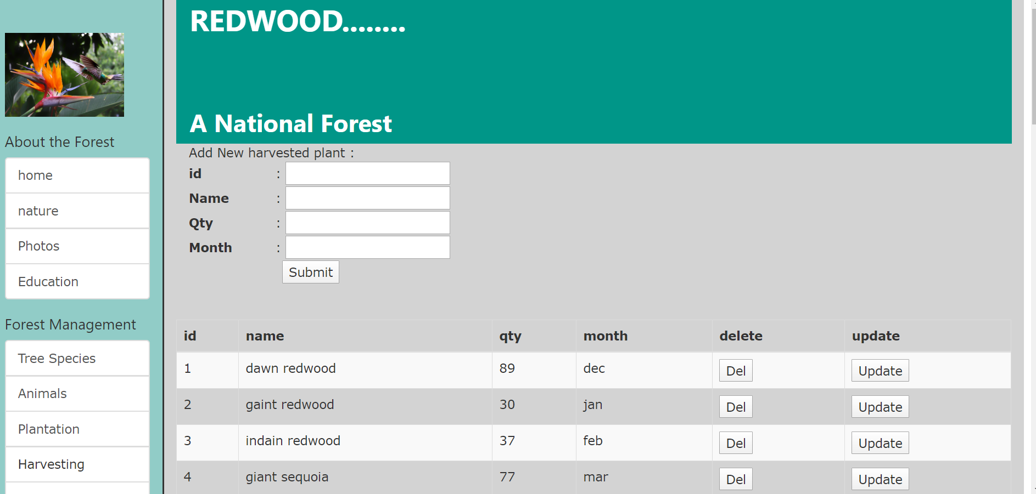

**News Channels page:** The news channels page allows the officer to send the information about the conditions of the forest to the local news media channels.

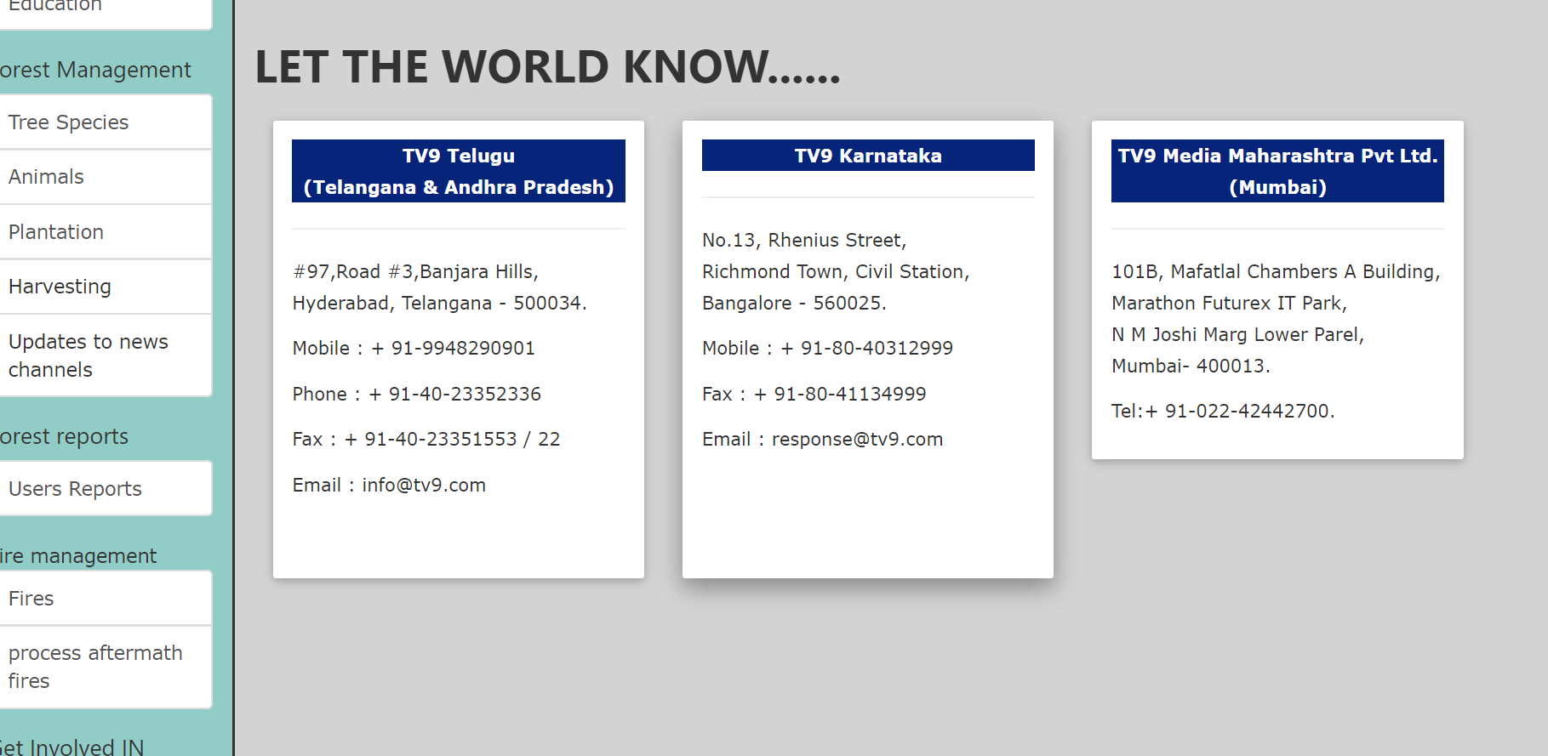

**Users Reports page:**

This user’s reports page shows the admin what the user had been reported in the users website.

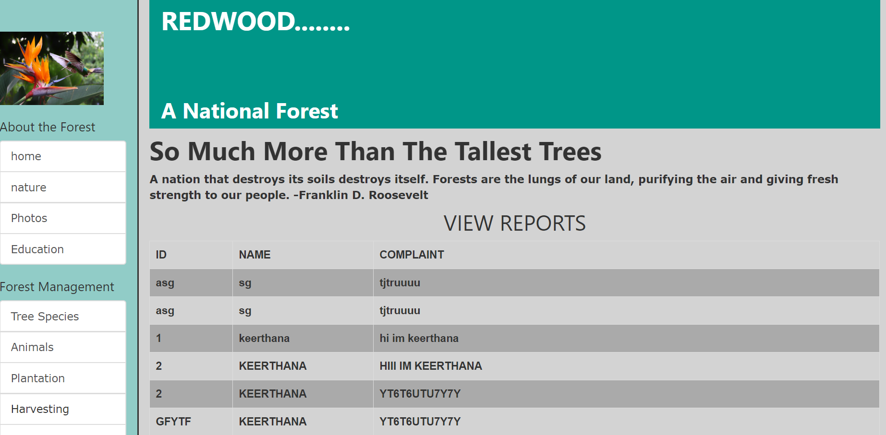

**Forest Fires page:**

The forest fires page displays the biggest fires that happened around the globe.

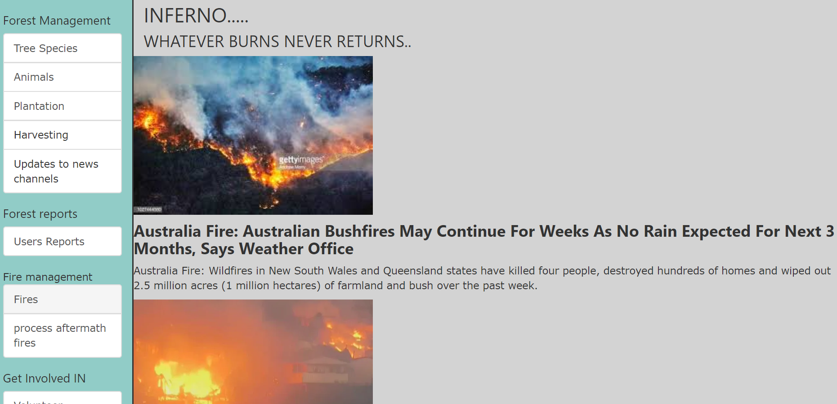

**Process Aftermath fire page:**

This page shows the precautions that must take before the forest fire.

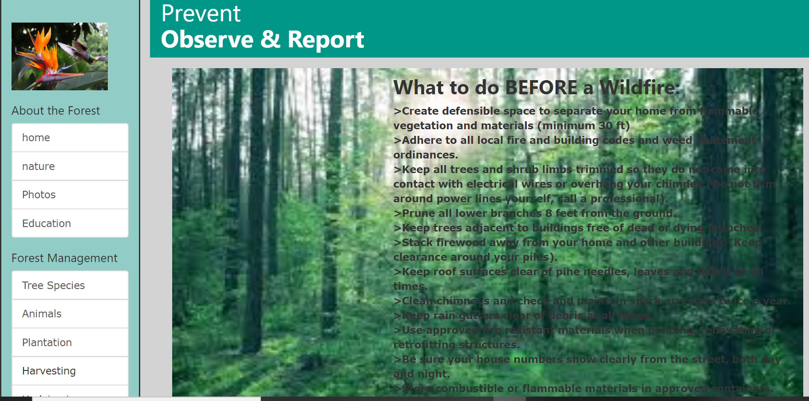

This shows the precautions during the forest fires.

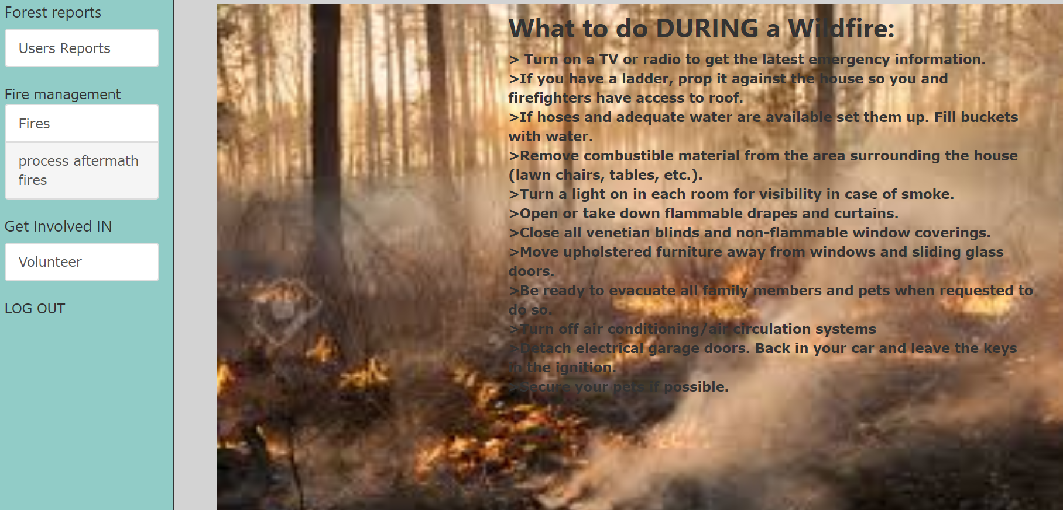

This shows the precaution after the forest fires.

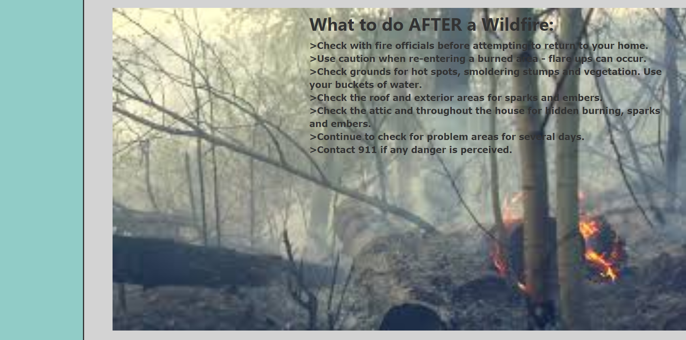

**Adventure page:**

This page shows the adventures that takes place in the forest for different age group of people.

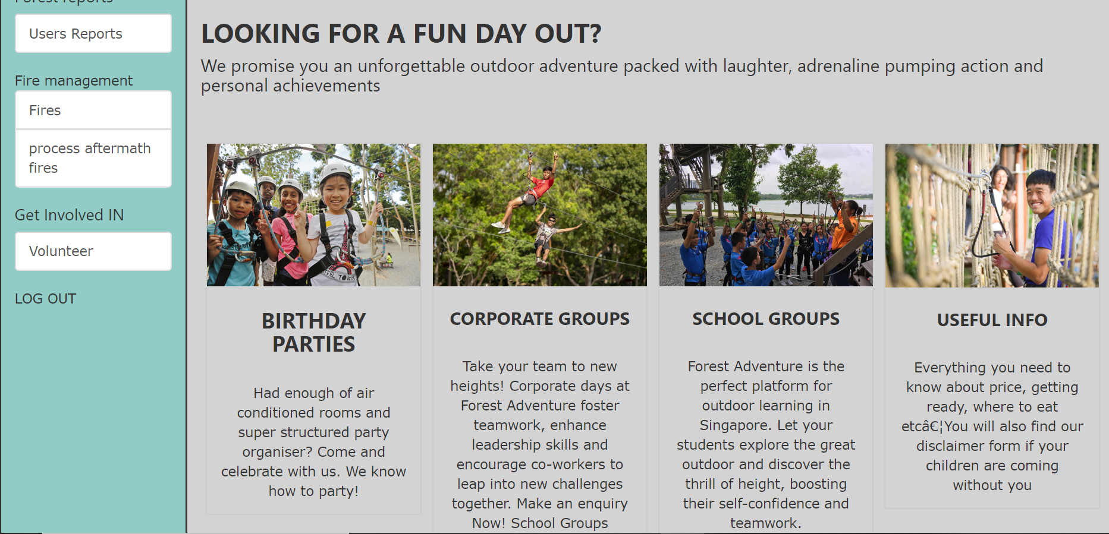

**USER’S PAGE:**

When the user logs in with his ID and Password the same home page appears with the details that users require. As the user website also contains the photos page, education page, nature page climate page and adventure page.

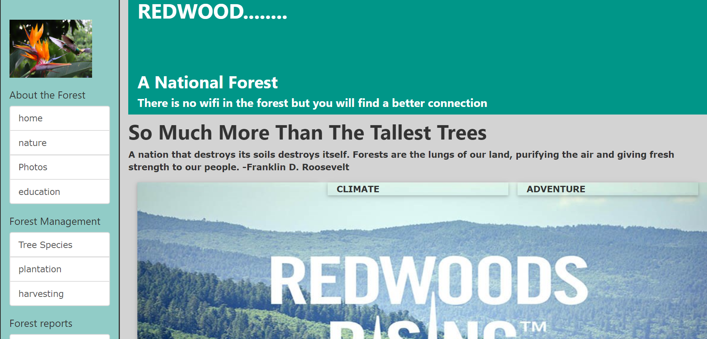

**User’s Tree Species page:**

The user’s tree species page shows the user the different kind of trees available in the forest with image of the tree.

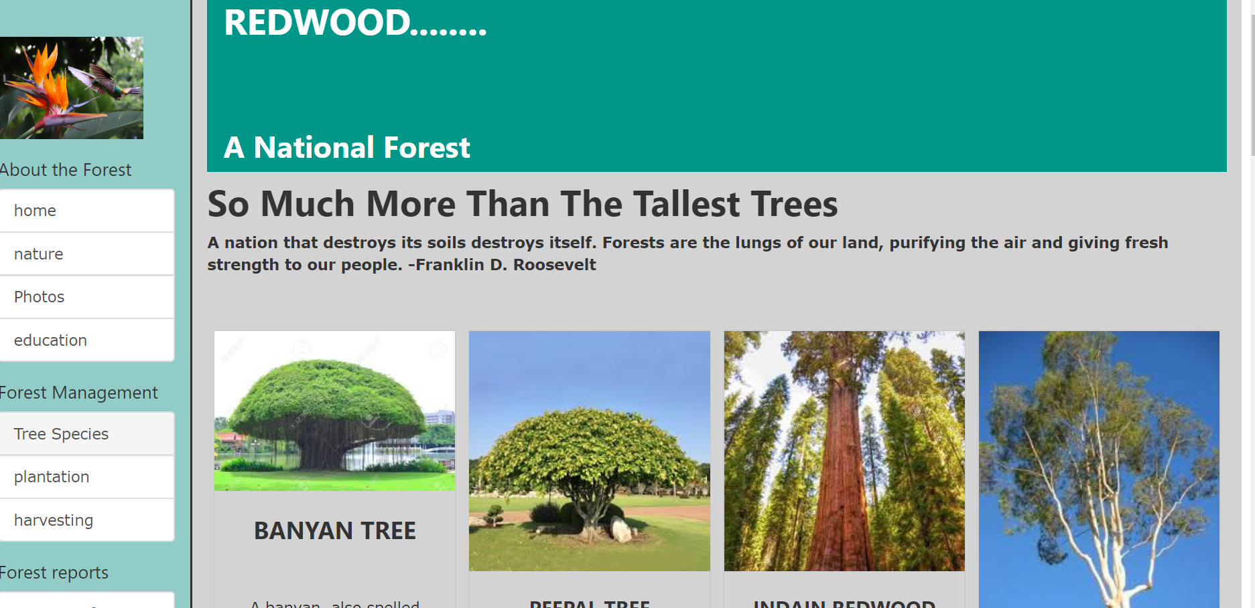

**User’s Plantation page:**

The user’s plantation page shows the different kind of plantation programs happening in the forest.

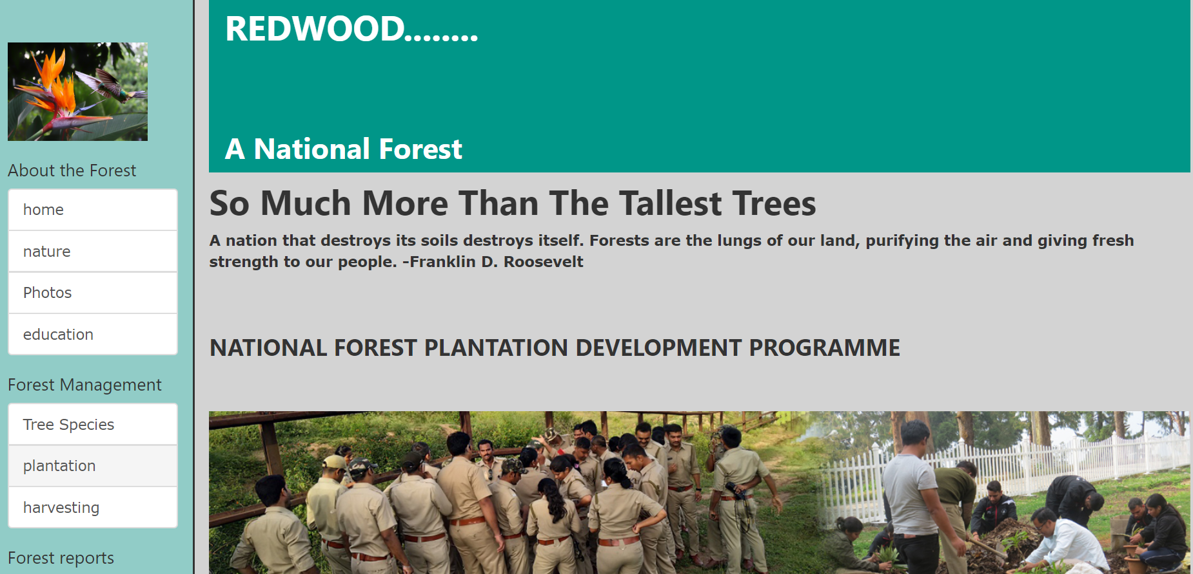

**Climate page:**

The climate page showcase the climatic conditions of the forest.

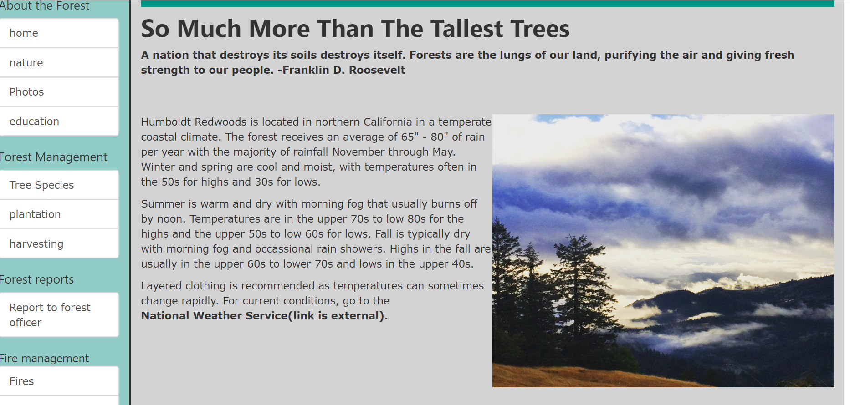

**Partners page:**

The partners page shows the partners that are related to the forest.

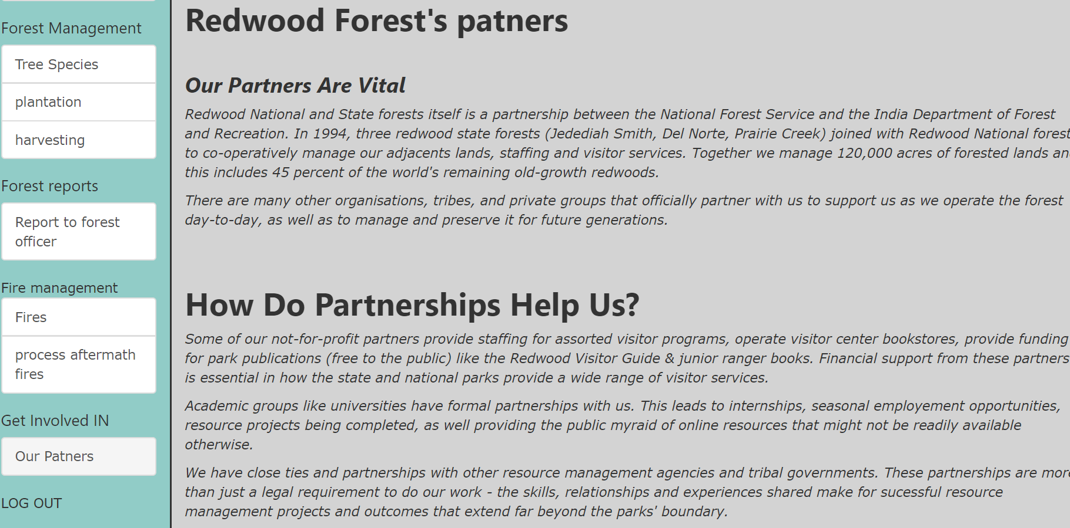

**User’s Reporting to forest officer page:**

The user’s reporting page allows the user to report to the forest officials about the problems that are faced by the users.

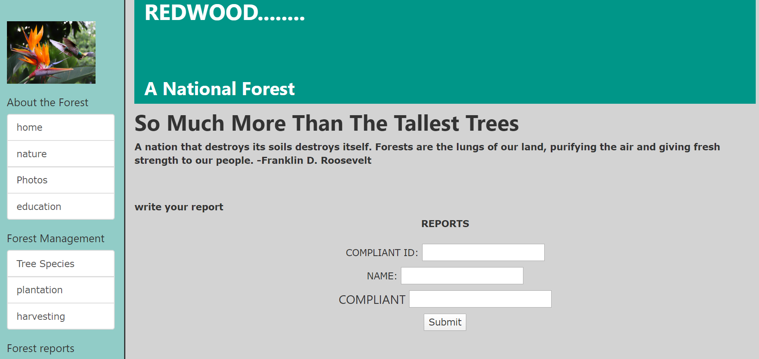

**Log out:**

When the user or admin wants to logout from the website, he can go to the logout option. Whenever the user or admin press the logout it redirects the page again to the login page.

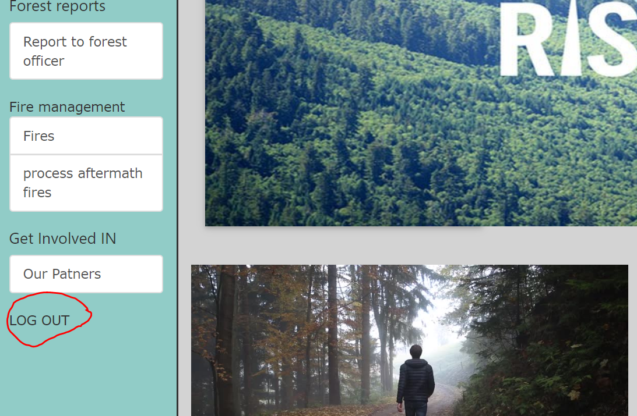

**10.FUTURE SCOPE OF PROJECT**

Ø   The future scope of forest management system interacts more with variety of the information related to forest.

Ø   we can also upload the videos about the awareness about the forest fires and the plantation programs.

Ø   We can also take online bookings for the adventure programs happening in the forest.

Ø We can also enhance the donating facilities to the forest.

**11. BIBLIOGRAPHY & WEBLIOGRAPHY**

➢    Core Java™ 2 Volume I – Fundamentals 7th Edition by Cay S. Hortsman

➢    Core Java™ 2 Volume II – Advanced by Cay S. Hortsman

➢    Pearson Education – Sun Microsystems By Gary Cornell

➢    Software Engineering

➢    Object-Oriented Analysis and Design with Applications

➢    Database Systems by Peter Rob

➢    Oracle software database

➢    Eclipse IDE for java

➢    [youtube.com](http://youtube.com/)

➢    <https://www.studentstutorial.com/jsp/jsp-scriptlet-tag.php>

➢    <https://tomcat.apache.org/tomcat-5.5-doc/servletapi/>